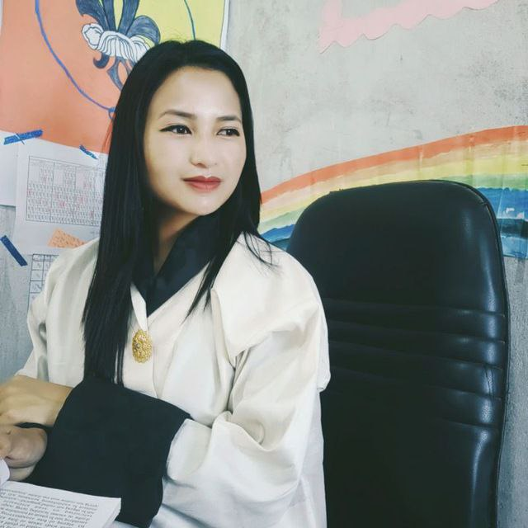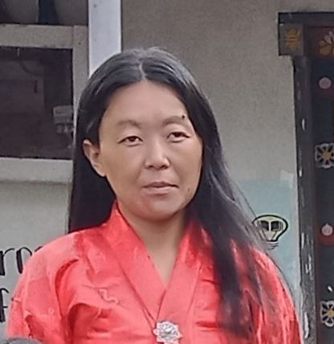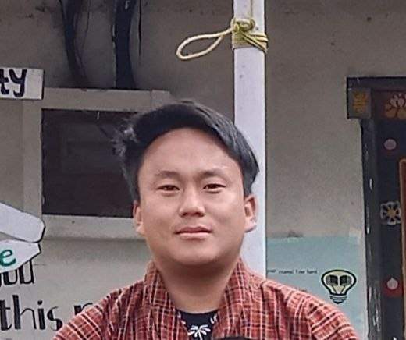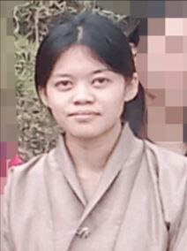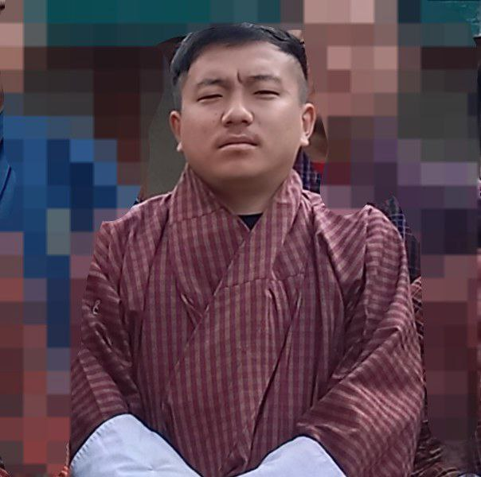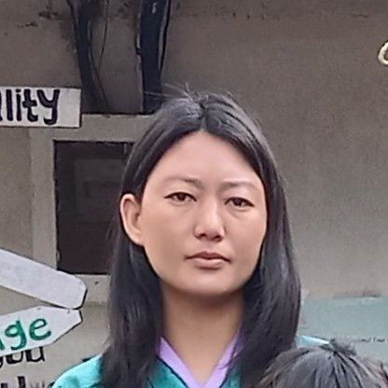

***Dorji Tshering***

***Principal, Mathematics***

***17658276***

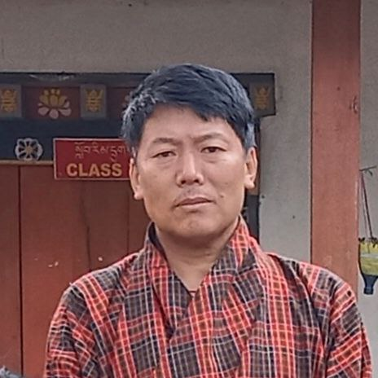

***Dorji Seldon***

***Teacher,General***

***17801824***

***Rinchen Pemo***

***Teacher, General***

***17310509***

***Chencho Dema***

***Teacher, Dzongkha***

***17712986***

***Tandin Lhamo***

***Teacher, General***

***17821195***

***Pema Zangmo***

***Teacher, Dzongkha***

***17787606***

***Pema Thinley***

***Teacher,General***

***17673659***



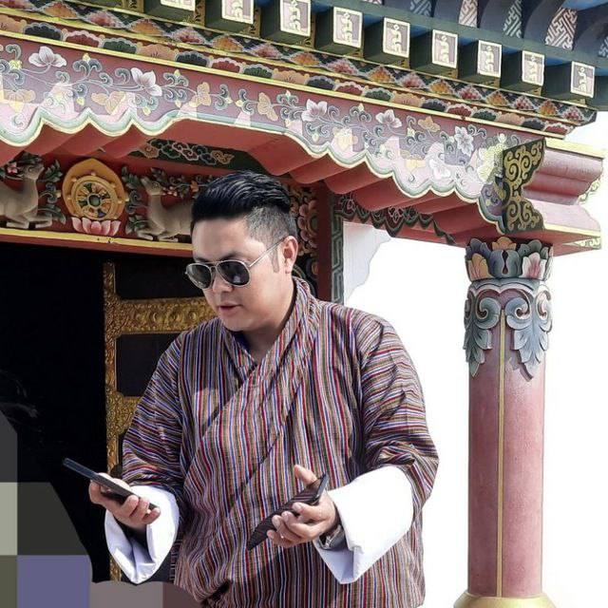

***Tshering Norbu***

***Teacher,General***

***17995173***

***Sonam Tshewang***

***Teacher, General***

***17389350***